

Southern California Edison
CS Re-Platform Project

CIM-CS-16 Manage Leads Opportunities and Territories
Customer Interaction Management
Business Process Maps
Version 1.2

RESPONSIBLE PARTIES

Contact | Contact Person(s)
Southern California Edison Business Integration Team | Ernesto Valle / Cari Young
Southern California Edison Business Team | Lori Blackwell / Scott Hirth / Janine Aumont
HCL Team | Balint Toth
OR (Org Readiness) Team | Jennifer Olivares Brown

APPROVAL HISTORY

Contact | Contact Person | Approved On
Southern California Edison Business Integration Approver | Ernesto Valle
Southern California Edison Business Approver | Lori Blackwell

REVISION HISTORY

Version # | Revision Date | Created/Updated By | Reason for Change
1.0 | 10/16/2019 | Shubham Mittal | Initial draft for Business Process Map Update
1.1 | 10/24/2019 | Shubham Mittal | Review comments incorporated
1.2 | 11/13/2019 | Shubham Mittal | Review comments incorporated

Process Flow Description
Customer Care Sales cycle
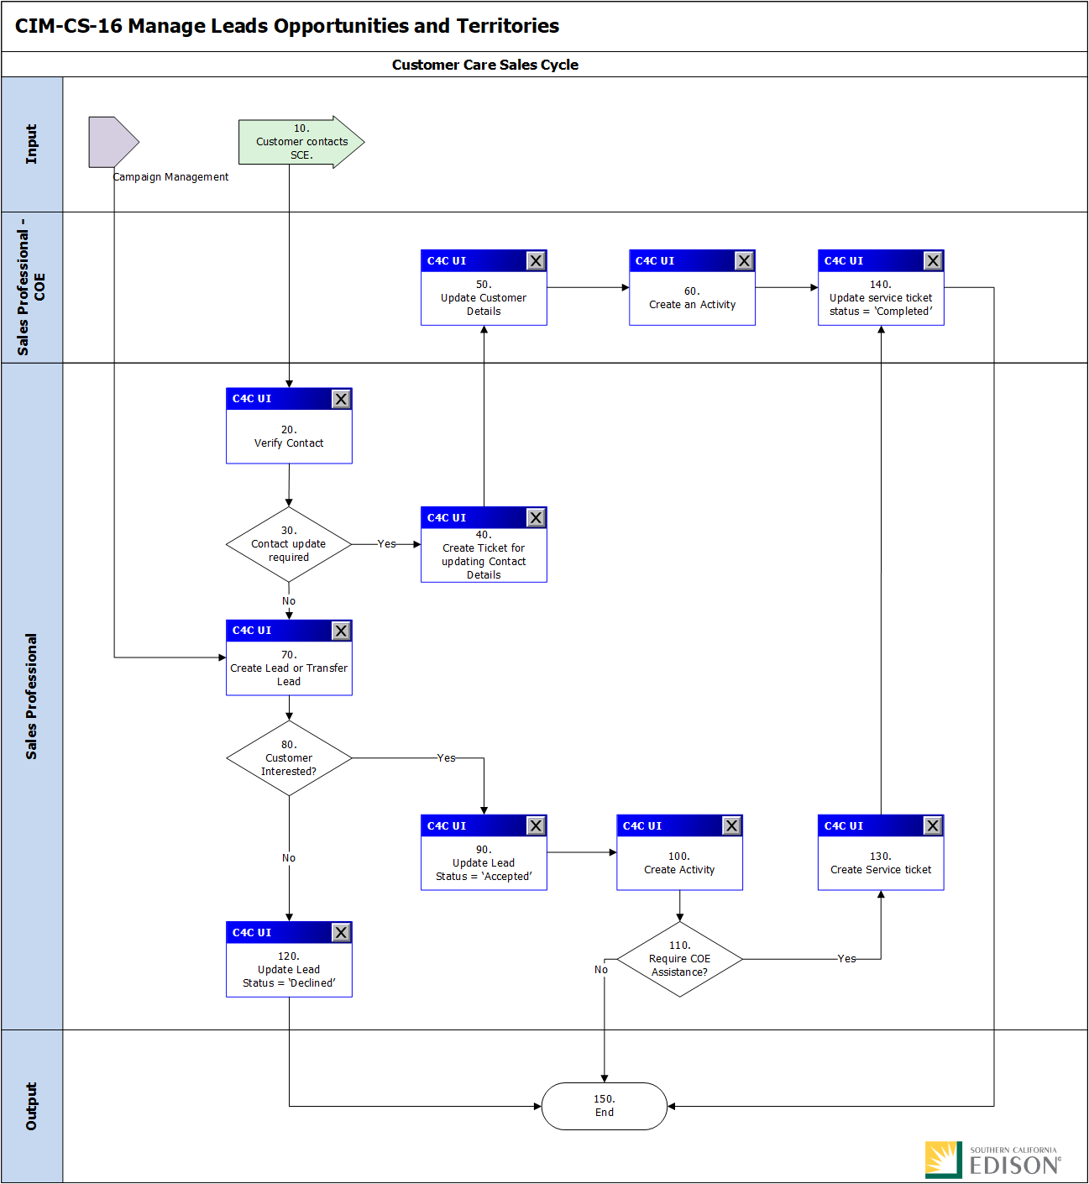

Step | Description of Step | C4C / T-Code | Role(s) | If step is relevant for a Control, add Requirement ID
10 | Process Input:  Customer Contacts SCE. | N/A | N/A | N/A
20 | Verify Contact  Contact Certification is done by Sales personnel to verify the customer | N/A | Sales Professional | N/A
30 | Contact Update Required  Sales Professional determines if Contact update is required by COE | N/A | Sales Professional | N/A
40 | Create Ticket  Sales Personnel will create a ticket if the delegation for contact certification is needed. | Activities → Activity Lists | Sales Professional | N/A
50 | Update Customer Details  COE updates the customer details | N/A | Sales Professional | N/A
60 | Create an Activity  COE creates an activity in C4C to capture the changes made to the Contact | N/A | Sales Professional | N/A
70 | Create Lead or Transfer Lead  If the input is Campaign Management, the user will perform a Lead Transfer from SAP Marketing Cloud to C4C, as opposed to creating a Lead directly in C4C. | N/A | Sales Professional | N/A
80 | Customer Interested?  Sales personnel will determine customer’s level of interest in the Customer Care program. If the customer is interested, proceed to step 60, otherwise, proceed to step 70. | N/A | N/A | N/A
90 | Update Lead Status = ‘Accepted’  Sales personnel will update the lead and set its status to ‘Accepted’. | Sales → Leads | Sales Professional | N/A
100 | Create Activity  Sales personnel will create an activity. | Sales → Opportunities | Sales Professional | N/A
110 | Require COE Assistance?  Sales personnel will determine whether COE assistance is needed. If COE assistance is needed, proceed to step 100,  otherwise, End. | N/A | N/A | N/A
120 | Update Lead Status = ‘Declined’  Sales personnel will update the lead and set its status to ‘Declined’. | Sales → Leads | Sales Professional | N/A
130 | Create Service Ticket  Sales personnel will create a Service Ticket and assign it to the COE based on the nature of the request. | Service → Tickets | Sales Professional | N/A
140 | Update Service Ticket Status = ‘Completed’  COE personnel will update the service ticket and set its status to ‘Completed’. | Service → Tickets | Sales Professional – COE | N/A
150 | End. | N/A | N/A | N/A

Economic Development Sales Cycle

Step | Description of Step | C4C / T-Code | Role(s) | If step is relevant for a Control, add Requirement ID
10 | Process Input:  Customer Contacts SCE. | N/A | N/A | N/A
20 | Identify Savings?  Sales personnel will identify the savings of the customer. If it is identified, proceed to step 30,  Otherwise, proceed to step 40. | N/A | Sales Professional | N/A
30 | Create Opportunity  Economic Development Services personnel will create an opportunity. | Sales → Opportunities | Sales Professional | N/A
40 | Create Lead  Sales personnel create a lead to capture customer’s intent to participate in or SCE’s intent to consider a customer for Economic Development initiatives. | Sales → Leads | Sales Professional | N/A
50 | Customer Contacted.  Additional details are gathered from the customer. | N/A | N/A | N/A
60 | Customer Interested?  Economic Development Services personnel will determine customer’s level of interest in the Economic Development program. If the customer is interested, proceed to step 70,  otherwise, proceed to step 80. | N/A | N/A | N/A
70 | Update Lead Status = ‘Accepted’  Economic Development Services personnel will update the lead and set its status to ‘Accepted’. Proceed to step 30. | Sales → Leads | Sales Professional | N/A
80 | Update Lead Status = ‘Declined’  Sales personnel will update the lead and set its status to ‘Declined’. | Sales → Leads | Sales Professional | N/A
90 | Require COE Assistance?  Economic Development Services personnel will determine whether COE assistance is needed. If COE assistance is needed, proceed to step 100,  otherwise, proceed to step 110. | N/A | N/A | N/A
100 | Create Service Ticket  Economic Development Services personnel will create a Service Ticket and assign it to the COE based on the nature of the request. | Service → Tickets | Sales Professional | N/A
110 | Follow-up with the Customer  Economic Development Services personnel will follow up with the customer. | N/A | N/A | N/A
120 | Update Opportunity  Economic Development Services personnel will update the opportunity. | Sales → Opportunities | Sales Professional | N/A
130 | Update Service Ticket Status = ‘Completed’  COE personnel will update the service ticket and set its status to ‘Completed’. | Service → Tickets | Sales Professional – COE | N/A
140 | Project Successful?  If the Project was successful, proceed to step 150,  otherwise, proceed to step 160. | N/A | N/A | N/A
150 | Update Opportunity Status = ‘Won’  Economic Development Services personnel will update the opportunity and set its status to ‘Won’. | Sales → Opportunities | Sales Professional | N/A
160 | Update Opportunity Status = ‘Lost’  Economic Development Services personnel will update the opportunity and set its status to ‘Lost’. | Sales → Opportunities | Sales Professional | N/A
170 | End. | N/A | N/A | N/A

New Construction Sales Cycle
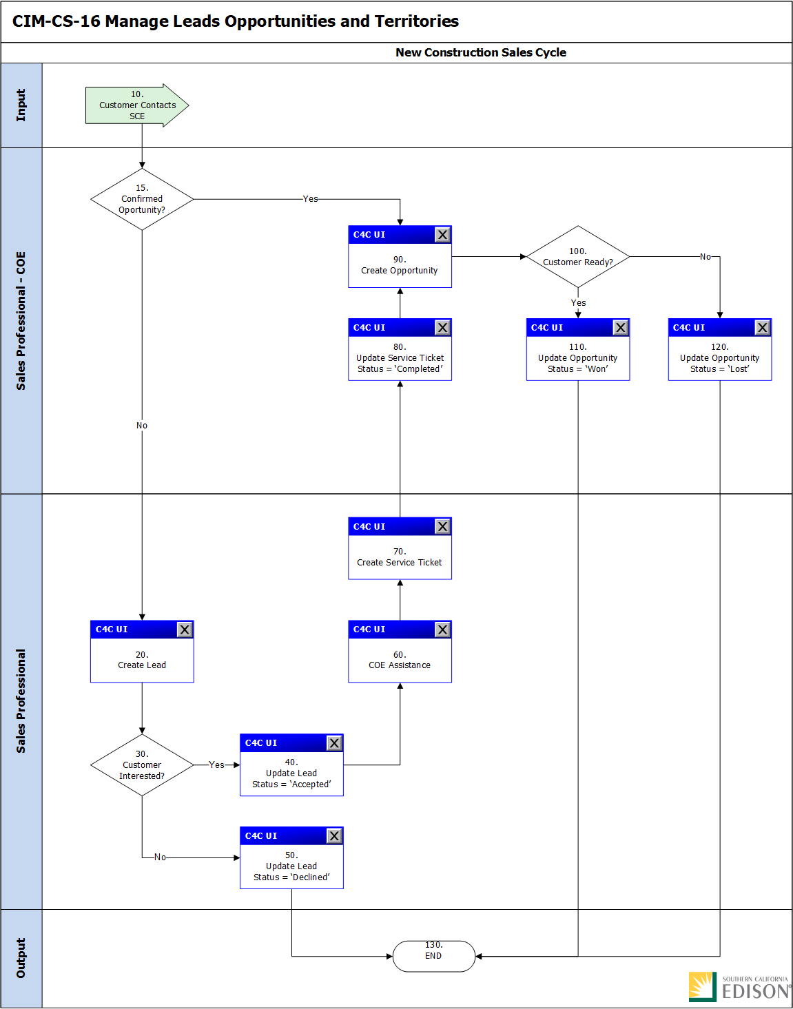

Step | Description of Step | C4C / T-Code | Role(s) | If step is relevant for a Control, add Requirement ID
10 | Process Input:  Customer Contacts SCE. | N/A | N/A | N/A
15 | Confirmed Opportunity?  Sales personnel COE will determine whether the opportunity is confirmed. If yes, proceed to step 90,  otherwise, proceed to step 20. | N/A | N/A | N/A
20 | Create Lead  Sales personnel will create a lead to capture customers intent to participate in or SCE’s intent to consider a customer for customer care initiatives.  Typically, no leads for New Construction. | Sales → Leads | Sales Professional | N/A
30 | Customer Interested?  Sales personnel will determine customer’s level of interest in the Customer Care program. If the customer is interested, proceed to step 40,  otherwise, proceed to step 50. | N/A | N/A | N/A
40 | Update Lead Status = ‘Accepted’  Sales personnel will update the lead and set its status to ‘Accepted’. | Sales → Leads | Sales Professional | N/A
50 | Update Lead Status = ‘Declined’  Sales personnel will update the lead and set its status to ‘Declined’. | Sales → Leads | Sales Professional | N/A
60 | COE Assistance  Sales personnel will determine whether COE assistance is needed. | N/A | Sales Professional | N/A
70 | Create Service Ticket  Sales personnel COE will create a Service Ticket. | Service → Tickets | Sales Professional – COE | N/A
80 | Update Service Ticket Status = ‘Completed’  COE personnel will update the service ticket and set its status to ‘Completed’. | Service → Tickets | Sales Professional – COE | N/A
90 | Create Opportunity  Sales personnel will create an opportunity. | Sales → Opportunities | Sales Professional – COE | N/A
100 | Customer Ready?  Sales personnel COE will determine whether the customer is ready to participate in the customer care initiative. If yes, proceed to step 110,  otherwise, proceed to step 120. | N/A | N/A | N/A
110 | Update Opportunity Status = ‘Won’  Sales personnel will update the opportunity and set its status to ‘Won’. | Sales → Opportunities | Sales Professional – COE | N/A
120 | Update Opportunity Status = ‘Lost’  Sales personnel will update the opportunity and set its status to ‘Lost’. | Sales → Opportunities | Sales Professional – COE | N/A
130 | End. | N/A | N/A | N/A

Rebate Program Sales Cycle
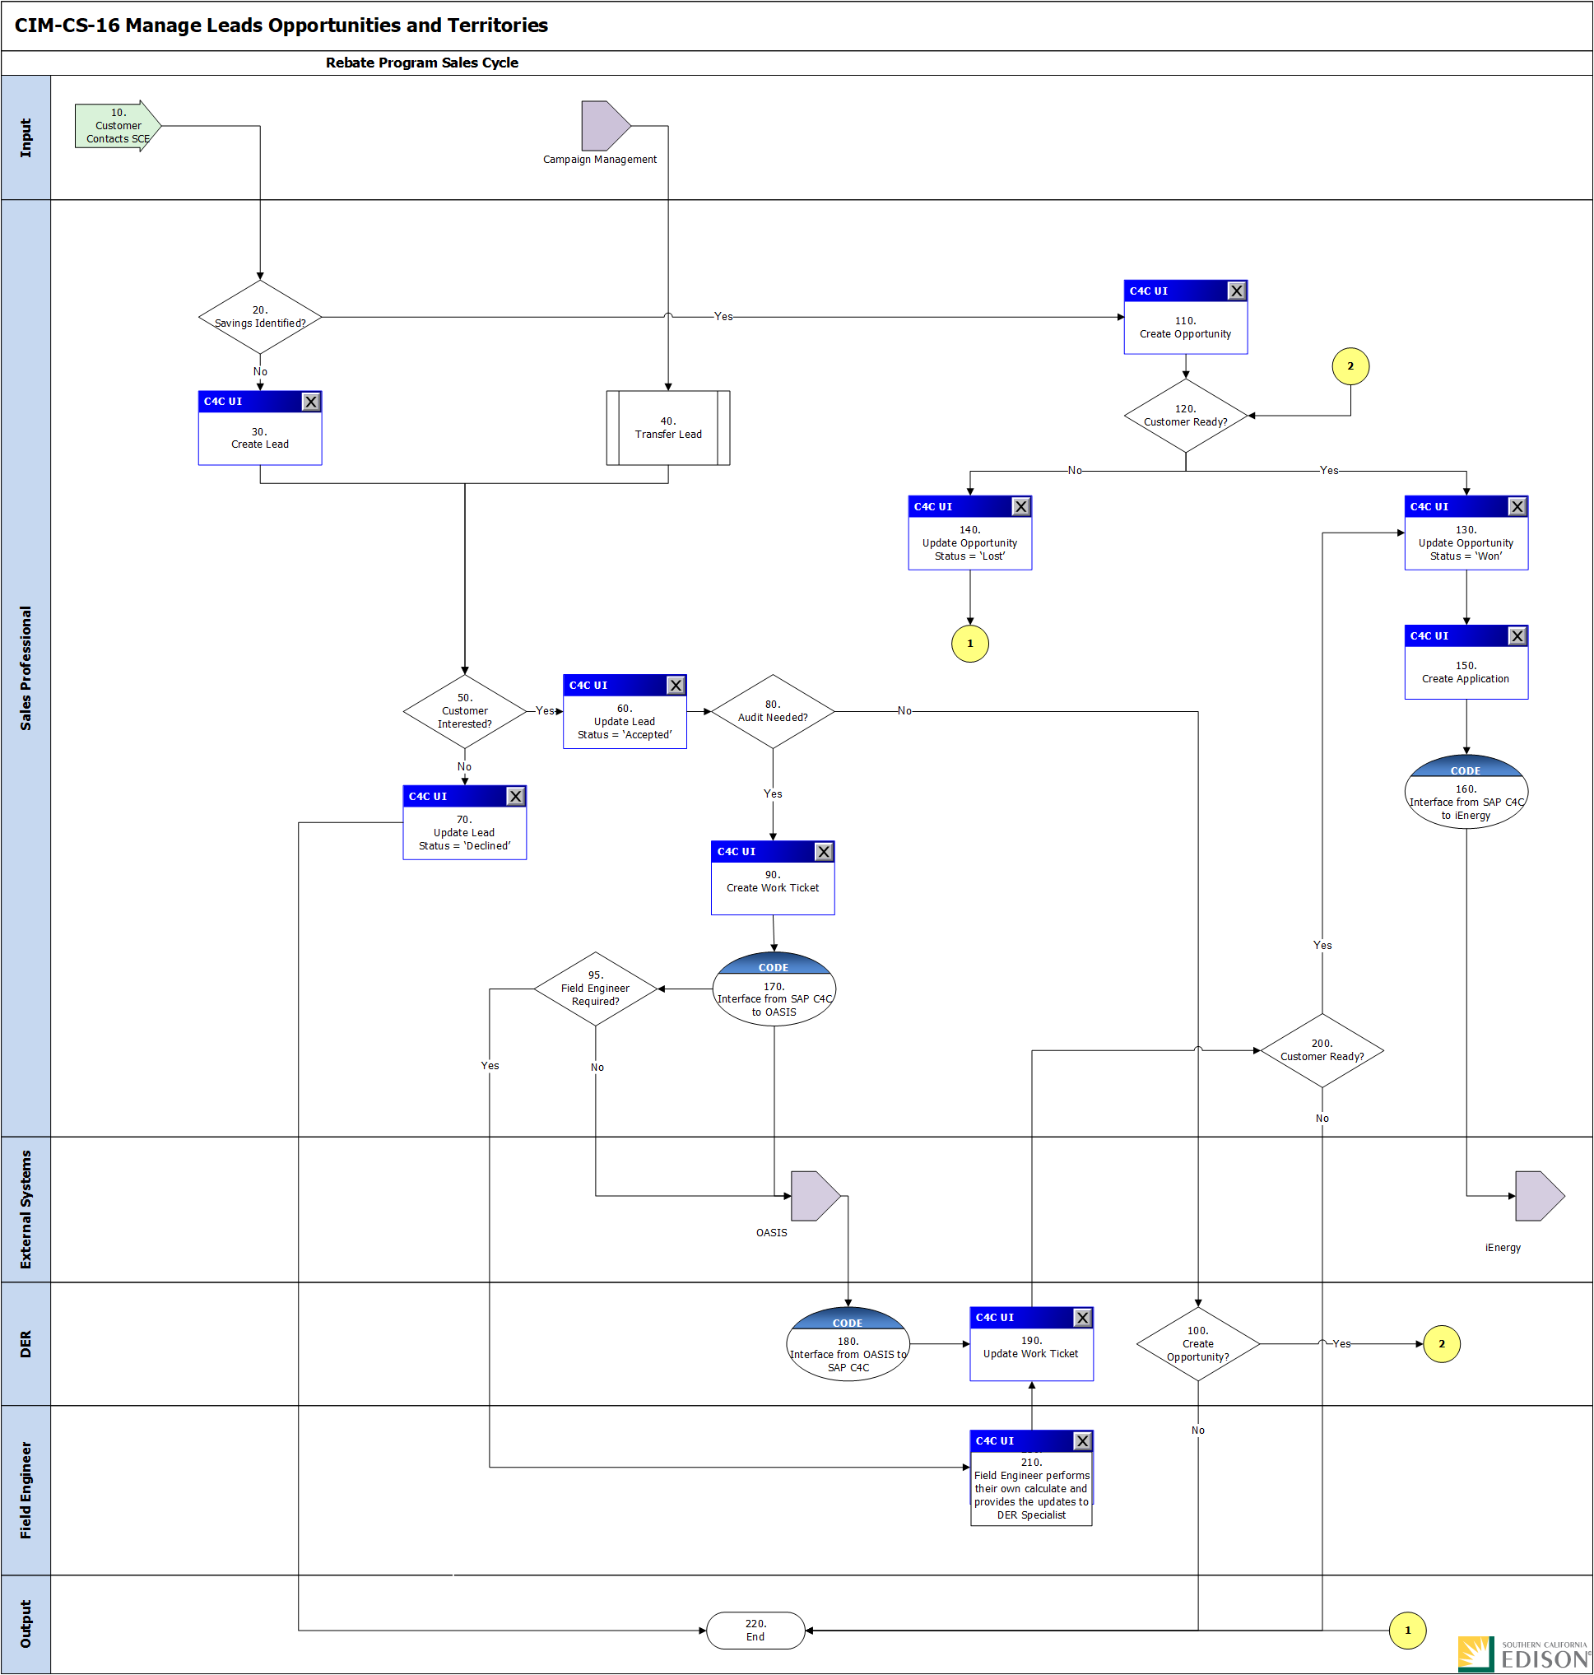

Step | Description of Step | C4C / T-Code | Role(s) | If step is relevant for a Control, add Requirement ID
10 | Process Input:  Customer Contacts SCE. | N/A | N/A | N/A
20 | Savings Identified?  Sales personnel will determine whether to create a Lead or an Opportunity. If savings for the rebate program are identified, proceed to step 110,  otherwise, proceed to step 30. | N/A | N/A | N/A
30 | Create Lead  Sales personnel create a lead to capture customer’s intent to participate in or SCE’s intent to consider a customer for Rebate Program initiatives. | Sales → Leads | Sales Professional | N/A
40 | Transfer Lead  Leads generated from Marketing will be transferred to SAP Hybris C4C. | N/A | Sales Professional | N/A
50 | Customer Interested?  Sales personnel will determine customer’s level of interest in the Rebate program. If the customer is interested, proceed to step 60, otherwise, proceed to step 70. | N/A | N/A | N/A
60 | Update Lead Status = ‘Accepted’  Sales personnel will update the lead and set its status to ‘Accepted’. | Sales → Leads | Sales Professional | N/A
70 | Update Lead Status = ‘Declined’  Sales personnel will update the lead and set its status to ‘Declined’. And Ends the process. | Sales → Leads | Sales Professional | N/A
80 | Audit Needed?  Sales personnel will determine whether an Energy Audit is needed to proceed with the Rebate Program opportunity. If an Energy Audit is needed, proceed to step 90, otherwise, proceed to step 100. | N/A | N/A | N/A
90 | Create Work Ticket  Sales personnel will create a Work Ticket as a follow-up of a Rebate Program Lead transaction. Proceed to step 170. | Service → Work Ticket | Sales Professional | N/A
100 | Create Opportunity?  Sales personnel will determine whether to create an opportunity. If an opportunity must be created, proceed to step 120,  otherwise, End. | N/A | N/A | N/A
110 | Create Opportunity  Sales personnel will create an opportunity. | Sales → Opportunities | Sales Professional | N/A
120 | Customer Ready?  Sales personnel will determine whether the customer is ready to move forward with the opportunity. If so, proceed to step 130, otherwise, proceed to step 140. | N/A | N/A | N/A
130 | Update Opportunity  Sales personnel will update the opportunity status as ‘Won’. | Sales → Opportunities | Sales Professional | N/A
140 | Update Opportunity  Sales personnel will update the opportunity status as ‘Lost’. | Sales → Opportunities | Sales Professional | N/A
150 | Create Application  Sales personnel will create an application. | N/A | Sales Professional | N/A
160 | Create an Application in iEnergy  Sales personnel will execute an action on the opportunity transaction in SAP Hybris C4C to trigger the creation of an application in iEnergy. | N/A | Sales Professional | N/A
170 | Send Open Work Tickets from SAP Hybris C4C to OASIS in response to a request from OASIS  Upon receiving a request from OASIS, all Work Tickets matching the criteria specified in the request will be sent from SAP Hybris C4C to OASIS. | N/A | Sales Professional | N/A
175 | Field Engineer Required?  Sales personnel will determine whether any Field Engineer is required. If yes, proceed to step 210,  otherwise, proceed to step 180 via OASIS. | N/A | N/A | N/A
180 | Send Completed Work Tickets from SAP OASIS to SAP Hybris C4C  Work Tickets that have been completed will be sent from OASIS to SAP Hybris C4C. | N/A | DER | N/A
190 | Update Work Ticket  Sales personnel will update the Work Ticket as needed | Service → Work Ticket | DER | N/A
200 | Customer Interested?  Sales personnel will determine customer’s level of interest in the Rebate program. If the customer is interested, proceed to step 130, otherwise, End. | N/A | N/A | N/A
210 | Field Engineer Performs their own calculations and provides the updates to DER specialist. | N/A | Field Manager | N/A
220 | End. | N/A | N/A | N/A

Territory Management- Annual Assignment
Step | Description of Step | C4C / T-Code | Role(s) | If step is relevant for a Control, add Requirement ID
10 | Process Input:  Customer Contacts SCE. | N/A | N/A | N/A
15 | Process Input:  Field Manager or Account Manager recommends Territory Change. | N/A | N/A | N/A
20 | Identify Customers.  BCD Field Manager will identify the Customers for Assignment and Re-assignment. | N/A | BCD Field Manager | N/A
30 | Segment Change Required?  BCD Manager will determine whether segment change is required to S1/S2/S4 etc. If yes proceed to step 40,  Otherwise, proceed to step 50. | N/A | N/A | N/A
40 | Review Customer Assignment Criteria. | N/A | BCD Field Manager | N/A
50 | Obtain Field Manager Approval.  BCD personnel will have to obtain Field Manager Approval. | N/A | BCD Field Manager | N/A
60 | Criteria Matched ?  BCD Field Manager will identify if the criteria are matched. If yes proceed to step 50,  Otherwise, proceed to step 70. | N/A | N/A | N/A
70 | Document Update.  BCD Field Manager will provide document justification for change. | N/A | BCD Field Manager | N/A
80 | Approval Received?  BCD Field Manager will determine if the approval is received. If yes, proceed to step 90,  Otherwise, proceed to step 10. | N/A | N/A | N/A
90 | New Territory Needed?  Sales Personnel will determine if the new territory needed. If yes, proceed to step 100,  Otherwise, proceed to step 110. | N/A | N/A | N/A
100 | Create Territory. | N/A | Sales professional COE | N/A
110 | Add Territory to Table. | N/A | IT Department | N/A
120 | Update Customer Assignment. | N/A | IT Department | N/A
130 | Validate Customer Assignments.  Sales Personnel COE will validate customer assignments. | N/A | Sales professional COE | N/A
140 | END. | N/A | N/A | N/A

Territory Management – Ad Hoc Assignment
Step | Description of Step | C4C / T-Code | Role(s) | If step is relevant for a Control, add Requirement ID
10 | Process Input:  Customer Contacts SCE. | N/A | N/A | N/A
20 | Identify Customers.  BCD Field Manager will identify the Customers for Assignment and Re-assignment. | N/A | BCD Field Manager | N/A
30 | Segment Change Required?  BCD Manager will determine whether segment change is required to S1/S2/S4 etc. If yes proceed to step 40,  Otherwise, proceed to step 50. | N/A | N/A | N/A
40 | Review Customer Assignment Criteria. | N/A | BCD Field Manager | N/A
50 | Obtain Field Manager Approval.  BCD personnel will have to obtain Field Manager Approval. | N/A | BCD Field Manager | N/A
60 | Criteria Matched ?  BCD Field Manager will identify if the criteria are matched. If yes proceed to step 50,  Otherwise, proceed to step 70. | N/A | N/A | N/A
70 | Document Update.  BCD Field Manager will provide document justification for change. | N/A | BCD Field Manager | N/A
80 | Approval Received?  BCD Field Manager will determine if the approval is received. If yes, proceed to step 90,  Otherwise, proceed to step 10. | N/A | N/A | N/A
90 | Create Service Ticket.  BCD Manager will create a service ticket. | N/A | BCD Field Manager | N/A
100 | Information Missing?  Sales Personnel will determine if the information is missing. If yes, proceed to step 110,  Otherwise, proceed to step 130. | N/A | N/A | N/A
110 | Request Information  Sales Personnel will request the information of the customer. | N/A | Sales professional COE | N/A
120 | Add Additional Information.  BCD Manager will add additional informational. | N/A | BCD Field Manager | N/A
130 | New Territory Needed?  Sales Personnel will determine if the new territory needed. If yes, proceed to step 140,  Otherwise, proceed to step 150. | N/A | N/A | N/A
140 | Create Territory. | N/A | Sales professional COE | N/A
150 | Personal Changes Needed?  Sales Personnel will determine if personal changes are needed. If yes proceed to step 170,  Otherwise, proceed to step 180. | N/A | N/A | N/A
160 | Add Territory to Table. | N/A | IT Department | N/A
170 | Account Management Personal Changes.  Personal changes related to account of the customer are updated. | N/A | Sales professional COE | N/A
180 | Customer Assignment Changes Needed?  Sales Personnel will determine if customer assignment changes are needed. If yes, proceed to step 200,  Otherwise, proceed to step 210. | N/A | N/A | N/A
190 | Update Customer Assignment. | N/A | Sales professional COE | N/A
200 | Complete Service Ticket Request  Sales personnel will update service ticket request to completed. | N/A | Sales professional COE | N/A
210 | Customer Care Cycle  Output of the Territories Management will go into Customer Care Sales Cycle. | N/A | N/A | N/A
220 | END. | N/A | N/A | N/A

